**Research publication**

**8) Research Publication Summary and relevance / potential relevance to your work**

**A] Publication & Researchers**

**Citation**

Gurram Sai Kumar. " Credit Card Fraud Detection System Based On Machine Learning Techniques." IOSR Journal of Computer Engineering (IOSR-JCE) 21.3 (2019): 45-52.

**Publication -** IOSR Journal of Computer Engineering (IOSR-JCE)

**Researchers -** Gurram Sai Kumar, Madala Vekaiah Naidu, Dr. Mandugula Sujatha

**B] Dataset**

• German Credit Card dataset obtained from the UCI (University of California, Irvine) machine learning repository

**C] Technique (mention any adaptions)**

In this research, ensemble models were the majority concerned.

Bagging is an ensemble algorithm that is used to improve factors such as stability and accuracy of a machine learning algorithm. Random Forest is another ensemble algorithm that helps to identify relevant predictor variables to make feature selection easier.

eXtreme Gradient Boosting (XGBoost) is a kind of GBM model that follows the principle of gradient boosting. The differences in modelling details that exist are that XGBoost uses a more regularized model formalization to control over-fitting which helps achieve better performance.

Light Gradient Boosting Machine (LightGBM) is a gradient boosting framework that works upon tree-based algorithms. Given its highly efficient and scalable behaviour it is capable of supporting many different GBM Algorithms. It is several times faster that most existing implementations of gradient boosting trees which is backed by its fully greedy tree-growth method, histogram-based memory and computation optimization.

Adaptive Boosting(AdaBoost) has been used as part of the implementation method in order to boost the performance of decision tree and has been implemented in WEKA(Waikato Environment for Knowledge Analysis).This boosting algorithm can be applied to any classifier’s learning algorithm.

## **D] Major Findings**

Two different forms of experimental results have been provided, which are:-

1) Experimental results of decision tree without any boosting techniques

2) Experimental results of the decision tree together with AdaBoost.

The proposed algorithm is a clear cut enhancement of the already available algorithms. Application of boosting algorithms in combination with these algorithms gives much higher accuracy. On analysis of various other features such as Sensitivity and Specificity , it can clearly be derived that the proposed algorithm does a better job than any existing technique. The only limitation encountered in the proposed algorithm is its non applicability to Linear data.

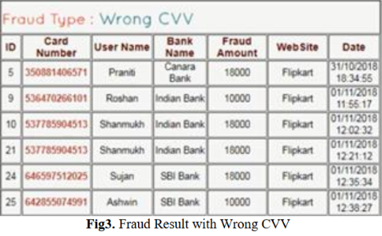

## 2

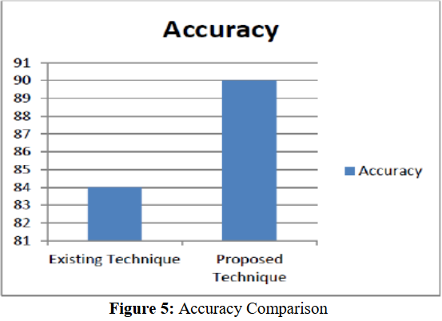

## 4

## **E] Relevance / potential relevance to your work**

The research paper gives an insight into making the existing algorithms better by addition of boosting algorithms. Since, we have used the basic techniques such as J48 tree, Voted Perceptrons, K-Means and Time Series Forecasting, we have only looked into the basic existing techniques that are possible to solve the problem of Credit Card Fraud. Adding of Boosting Algorithms to the techniques analysed in this report would be a beneficial task. We can further investigate into ways to enhance the current models and come up with the best approach after analysing it on various factors of accuracy , sensitivity and specificity.

**REFERENCE** - http://www.iosrjournals.org/iosr-jce/papers/Vol21-issue3/Series-5/H2103054552.pdf